Fran Griffith
Posture Assessment Clinic
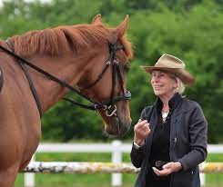

When: Saturday 30th July
Where: Penygraig, Nebo, Ceredigion, SY23 5LE
Price: £50 for 45min session
Contact: Emma Brooke - 07779306895 / brookshe@yahoo.co.uk / Facebook

Please note, there is a maximum height limit of 6’ 2” (1.87m) and weight limit of 15 stone (95kg)

